TASK ACCOMPLISHED IN ORGANIZATION

4.1 Development of Radiation Dataset
The first phase of the project involved developing a structured radiation dataset to support visualization and analysis. Radiation readings, GPS coordinates, environmental parameters, and timestamps were organized into a standardized format. The prepared dataset was published on Kaggle to facilitate research, testing, and future model development. This dataset served as the foundation for generating radiation heatmaps and validating visualization algorithms.
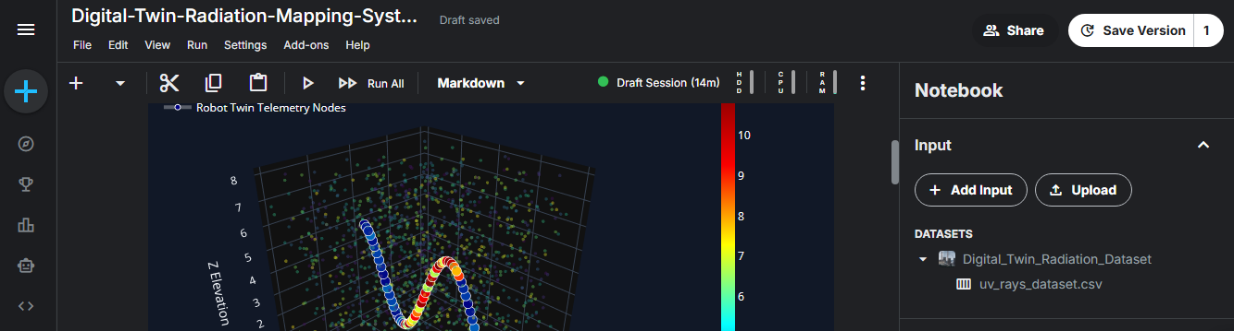
Figure 1: Kaggle Dataset (Dataset page or CSV preview)

4.2 Development of 2D Radiation Heatmap
A two-dimensional (2D) radiation heatmap was developed to visualize the spatial distribution of radiation intensity over geographical locations. The system utilized radiation measurements acquired from the Gamma Spectrometer and synchronized them with real-time GPS coordinates obtained from the GlobalSat BU-353N GPS Receiver. Each radiation reading was mapped to its corresponding geographical location, enabling accurate visualization of radiation levels across the monitored area.
The generated heatmap represented radiation intensity using a color gradient, where lower radiation levels were displayed in cooler colors (blue and green) and higher radiation levels in warmer colors (yellow, orange, and red). This visualization made it easier to identify radiation hotspots and analyze the spatial variation of radiation within the surveyed region.
To enhance the analysis, additional parameters such as radiation count rate, peak channel, GPS coordinates, timestamp, temperature, and humidity were integrated into the mapping process. These parameters provided a comprehensive overview of environmental conditions alongside radiation measurements, improving the accuracy and reliability of the visualization.
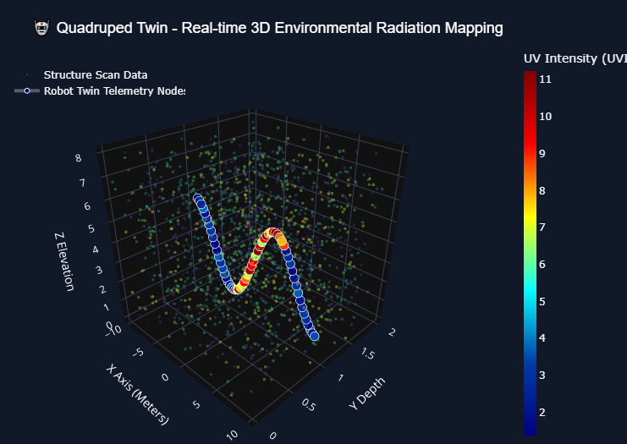
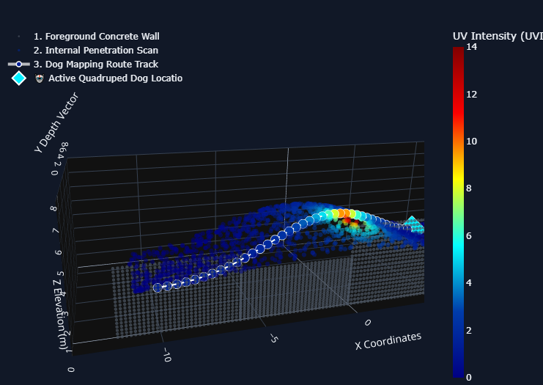
Figure 2: Static 2D Radiation Heatmap Output Generation with Dataset
4.3 GPS Integration with Raspberry Pi-5
The successful implementation of the RADMAP system required precise geographical positioning to accurately map radiation measurements. For this purpose, the GlobalSat BU-353N USB GPS Receiver was integrated with the Raspberry Pi-5 to acquire real-time positioning data from GPS satellites. The GPS receiver communicates with the Raspberry Pi through the USB interface and continuously provides NMEA (National Marine Electronics Association) sentences containing essential navigation information.
A Python-based data acquisition module was developed to extract and process GPS information, including latitude, longitude, altitude, UTC time, speed, satellite status, and positioning accuracy. Along with GPS telemetry, environmental parameters such as temperature and humidity were also acquired using the DHT22 sensor and synchronized with the location data. This integration enabled the simultaneous collection of geographical and environmental information during radiation monitoring.
The collected GPS coordinates were directly associated with radiation counts received from the Gamma Spectrometer, allowing every radiation measurement to be mapped to its exact geographical position. This synchronized dataset formed the basis for generating interactive 2D radiation heatmaps and later served as the input for the 3D Digital Twin visualization system.
Special attention was given to real-time communication and data synchronization to ensure minimal latency between sensor readings and GPS updates. Python serial communication libraries were used to continuously monitor incoming GPS data, parse NMEA messages, and store the processed information in structured datasets for further analysis and visualization. The integrated system provided a reliable telemetry framework capable of supporting future mobile radiation monitoring and autonomous navigation applications.
The successful integration of GPS technology significantly enhanced the capability of the RADMAP system by enabling real-time geospatial radiation mapping, accurate environmental data logging, and seamless synchronization with the backend visualization platform.

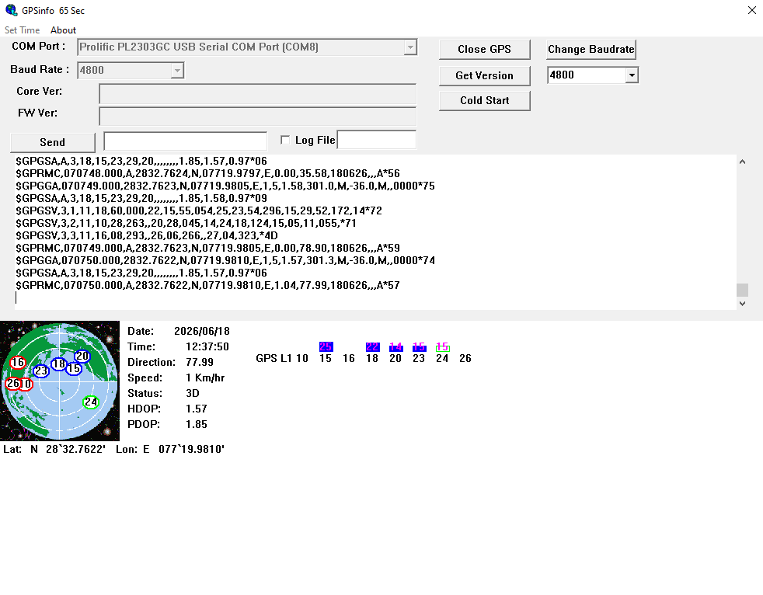
Figure 3: Live GPS Data Terminal Output

4.4 Gamma Spectrometer Integration and Radiation Validation
A critical component of the RADMAP system is the CNSPEC Multi-Channel Analyzer (Gamma Spectrometer), which was integrated to perform real-time gamma radiation detection and spectral analysis. The Gamma Spectrometer measures the energy and intensity of gamma radiation emitted by radioactive materials, enabling accurate identification and quantitative analysis of radiation levels.
During the internship, the spectrometer was configured and interfaced with the Raspberry Pi-based backend for continuous acquisition of radiation measurements. Experimental validation of the detector was performed using certified radioactive calibration sources, including Cobalt-60 (Co-60) and Cesium-137 (Cs-137). These sources were selected because of their well-defined gamma energy peaks, making them suitable for detector calibration and performance evaluation.
Based on the collected radiation measurements, Python-based visualization modules were developed to display radiation count rates, peak channels, intensity graphs, and statistical metrics. These processed measurements were further synchronized with GPS coordinates, enabling the generation of location-aware radiation maps.
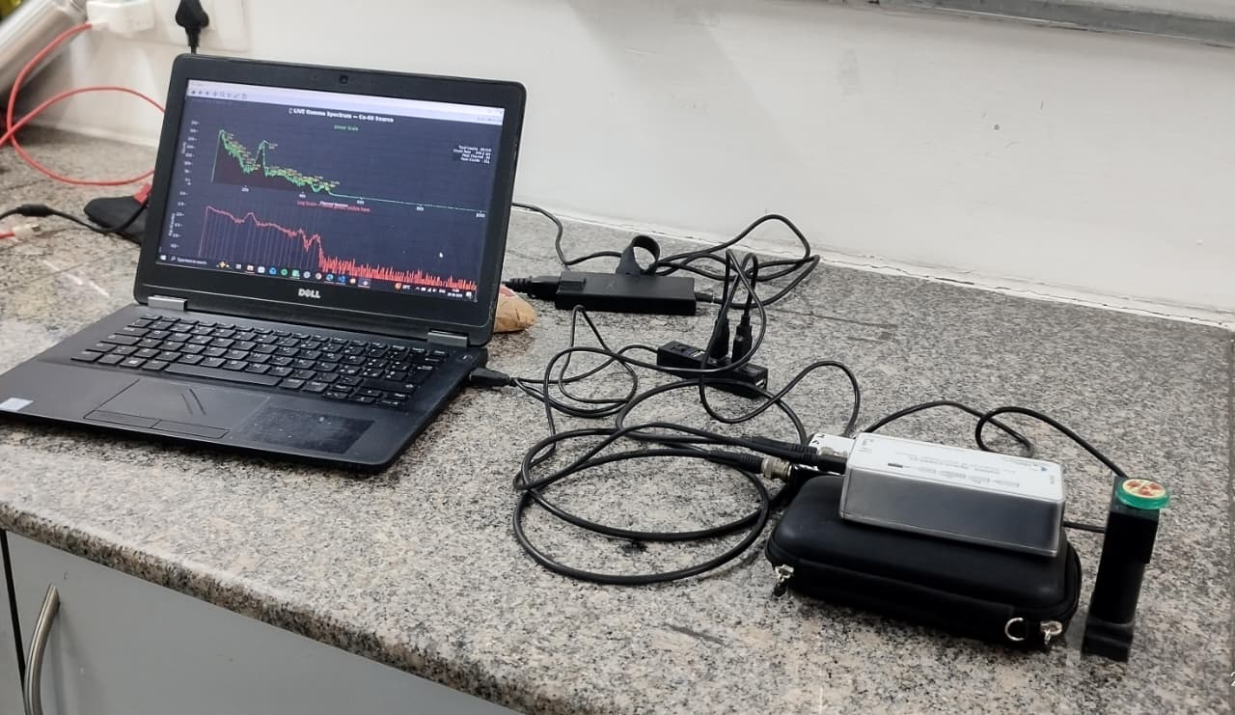
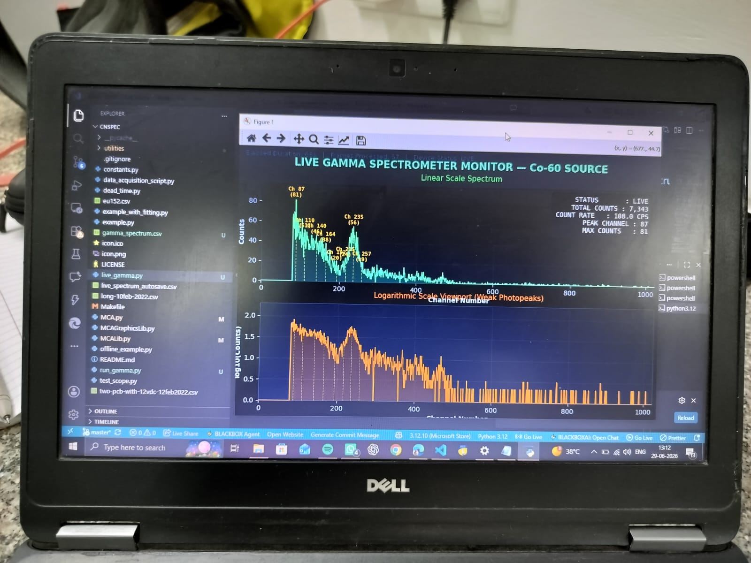
Figure 4: Gamma Spectrometer Setup, Co-60 and Cs-137 Radiation Testing
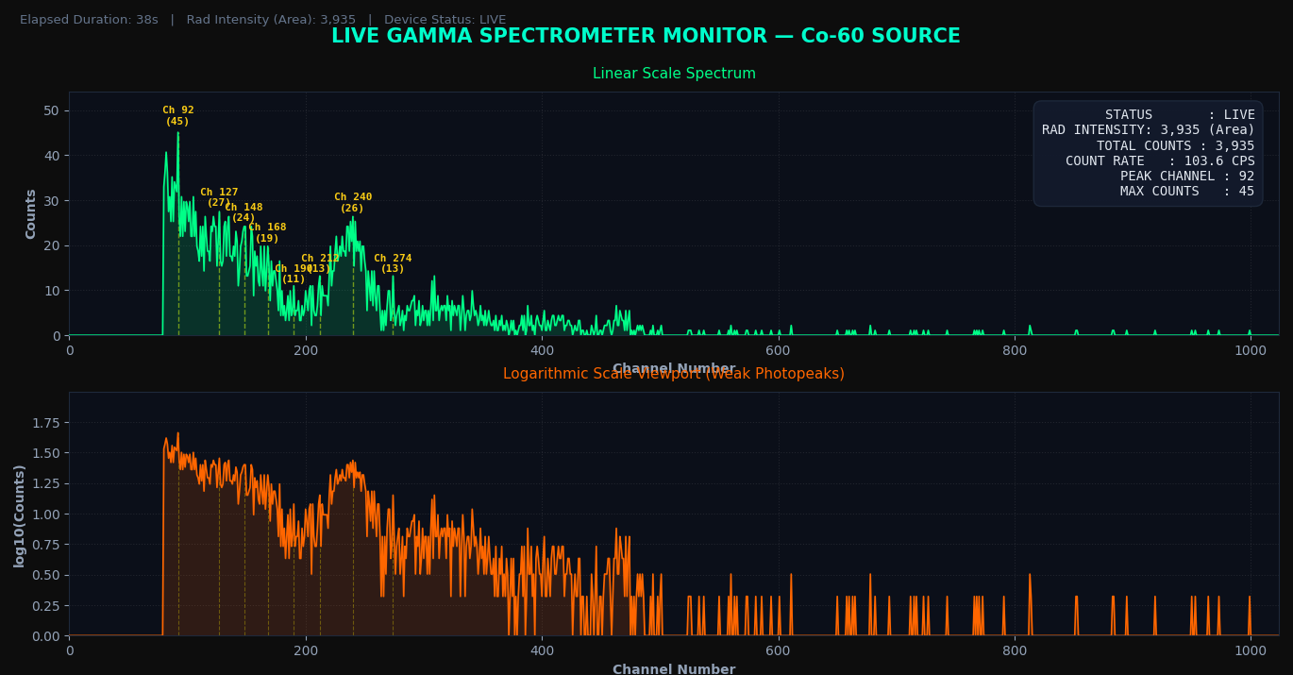
Figure 5: Gamma Spectrum / Peak Detection Graph with Metrics and Radiation Intensity 2D Dynamic Heatmap Generation on real-time basis.
The integration of the Gamma Spectrometer established a robust foundation for continuous radiation monitoring and provided reliable input data for both 2D heatmap generation and 3D Digital Twin visualization. The successful validation confirmed that the developed system can accurately detect radiation levels while maintaining stable real-time operation.

4.5 Development of 3D Digital Twin
The initial implementation of the RADMAP system successfully generated 2D radiation heatmaps, which effectively represented radiation intensity over geographical locations. However, during system evaluation it was observed that conventional heatmaps only indicate the distribution of radiation levels and do not provide information about the probable origin or spatial location of the radioactive source. This limitation motivated the research and development of a 3D Digital Twin capable of providing enhanced spatial visualization.
A Digital Twin is a virtual representation of a physical environment that continuously receives real-time sensor data and accurately reflects changes occurring in the monitored area. In this project, a three-dimensional visualization framework was developed by integrating GPS coordinates, gamma radiation measurements, environmental sensor data, and live camera feedback into a unified virtual environment.
The developed backend continuously synchronized radiation intensity with camera frames and corresponding geographical coordinates to create a dynamic representation of the monitored environment. Unlike conventional heatmaps, the Digital Twin enables users to observe radiation distribution within a three-dimensional spatial context, significantly improving environmental understanding and situational awareness.
To further enhance visualization, a night vision-inspired color grading system was designed in which different radiation intensity levels were represented using multiple color gradients. Low radiation regions were displayed using cooler colors, while high-intensity regions were highlighted using warmer colors, allowing radiation hotspots to be identified instantly during live monitoring.
The Digital Twin architecture was designed to be modular and scalable, enabling future integration of LiDAR sensors, SLAM (Simultaneous Localization and Mapping), AI-based radioactive source localization, autonomous robotic navigation, and drone-assisted radiation mapping. This research forms the foundation for the next generation of intelligent radiation monitoring systems.
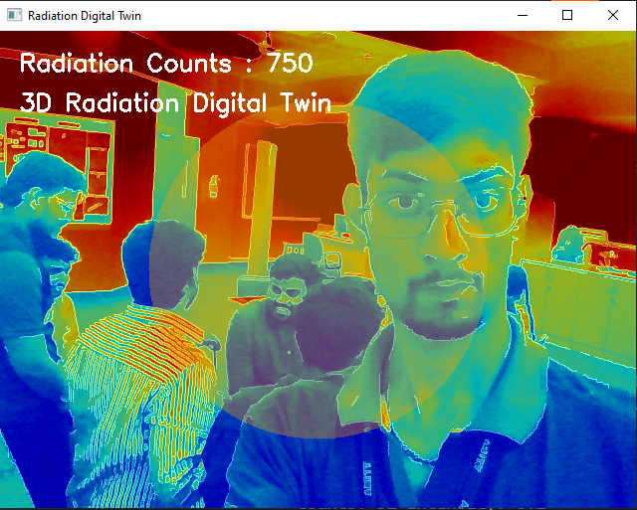
Figure 6: 3D Digital Twin Visualization
A real-time color grading algorithm inspired by night vision imaging technology was designed to represent varying radiation intensity levels. Different colors were assigned according to measured radiation counts, allowing intuitive identification of radiation hotspots directly on the live camera feed. This approach significantly improves visualization and situational awareness during radiation monitoring.

4.6 Backend System Developments
The backend system was developed to integrate all RADMAP components into a single platform for real-time radiation monitoring. It established communication between the Raspberry Pi-5, Gamma Spectrometer, GlobalSat BU-353N GPS Receiver, environmental sensors, and camera module. The system synchronized radiation measurements, GPS coordinates, temperature, humidity, and timestamp data to generate 2D heatmaps and support 3D Digital Twin visualization. This integrated architecture ensures smooth data processing and provides a scalable foundation for future enhancements such as AI-based source localization and autonomous radiation monitoring.
Key Outcomes
• Integrated all hardware components into a unified backend.
• Enabled real-time sensor data acquisition and synchronization.
• Supported 2D heatmap and 3D Digital Twin visualization.
• Developed a reliable data processing pipeline.
• Built a scalable architecture for future RADMAP enhancements.

4.7 End-to-End Architecture of the GPS-Enabled Radiation Mapping System
A 3D prototype model of the RADMAP system was designed to represent the final hardware architecture, incorporating the Raspberry Pi-5, Gamma Spectrometer, GlobalSat BU-353N GPS Receiver, environmental sensors, and camera module. Along with the physical prototype, a 3D SLAM (Simultaneous Localization and Mapping) model was developed to create a digital representation of the surrounding environment. The SLAM model serves as the foundation for the 3D Digital Twin, enabling real-time mapping, visualization, and future radioactive source localization. The complete prototype provides a scalable platform for field deployment, autonomous navigation, and advanced radiation monitoring applications.
The proposed RADMAP architecture follows a four-layer framework consisting of the AIoT Sensor Layer, Data Integration Layer, Digital Twin Modeling Layer, and Decision Intelligence Layer. The AIoT layer collects real-time radiation measurements, GPS coordinates, temperature, humidity, and camera data using the Gamma Spectrometer, GlobalSat BU-353N GPS Receiver, Raspberry Pi-5, and environmental sensors. The Data Integration Layer preprocesses, synchronizes, and stores the acquired data for further analysis. The Digital Twin Modeling Layer generates 2D radiation heatmaps and a 3D Digital Twin by integrating GPS, SLAM, and live camera feedback to provide enhanced spatial visualization and support future radioactive source localization. Finally, the Decision Intelligence Layer presents the processed information through interactive dashboards, radiation analytics, and real-time visualization, enabling effective radiation monitoring, decision-making, and future AI-based autonomous mapping applications.
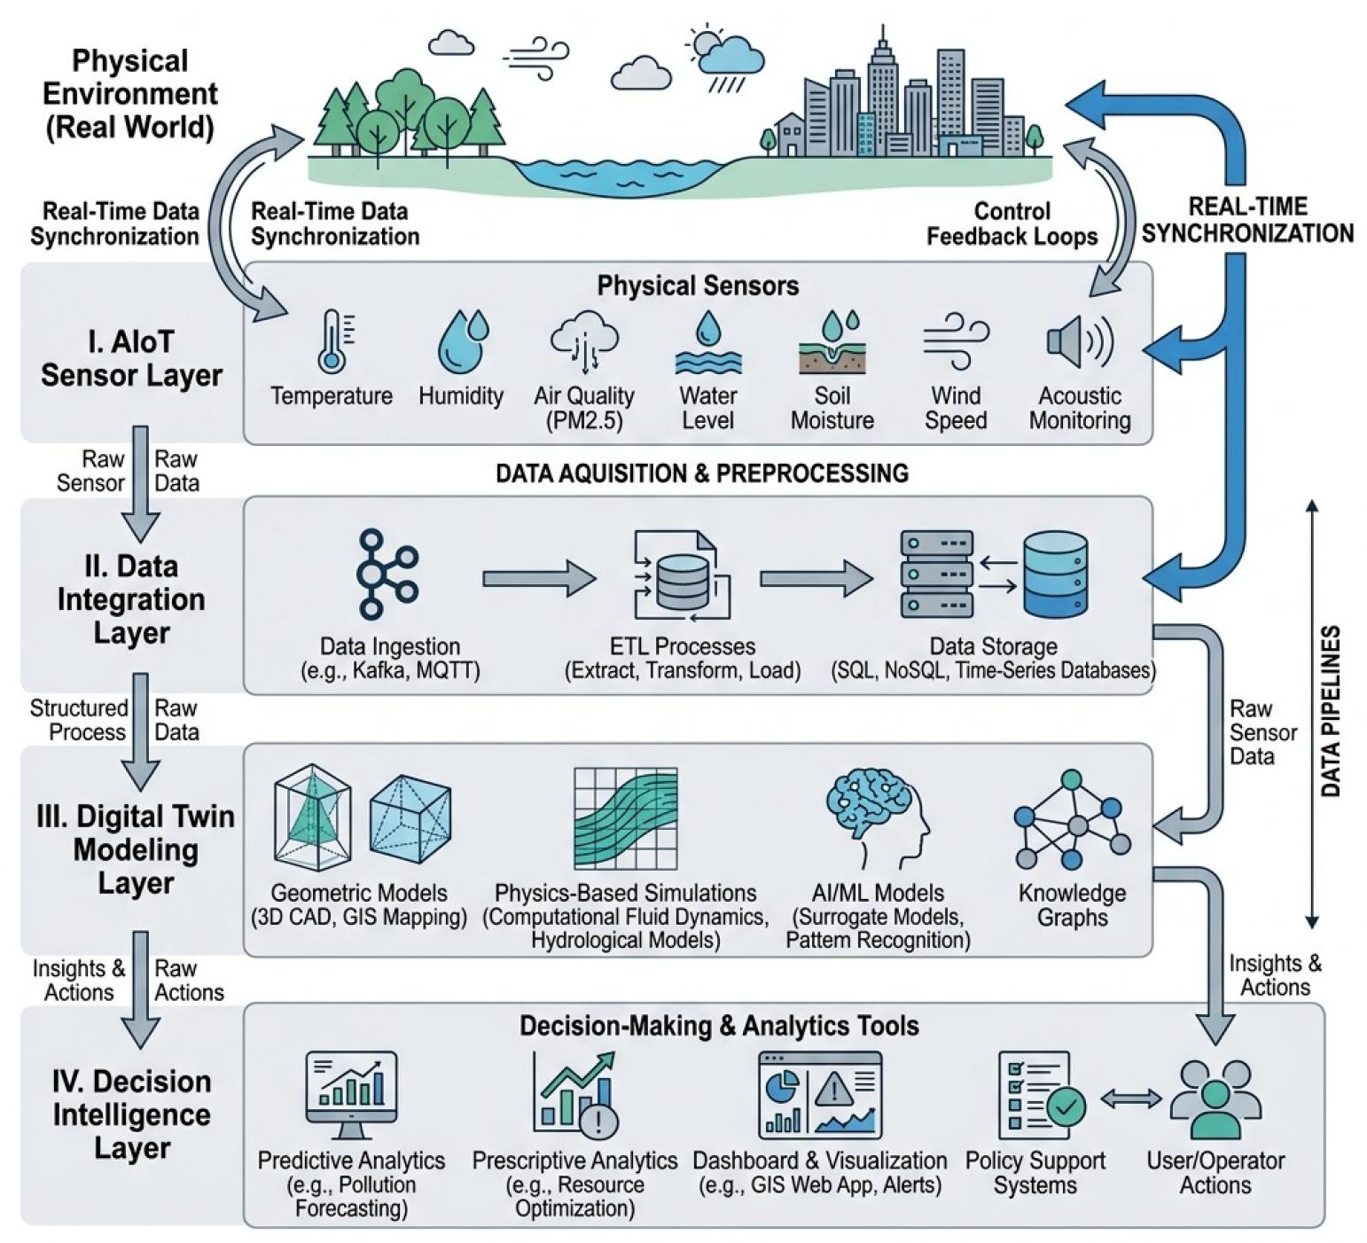
Figure 7: Overall Architecture of the RADMAP System
4.8 Prototype Design and SLAM Model
A 3D prototype model of the RADMAP system was designed to represent the final hardware architecture, incorporating the Raspberry Pi-5, Gamma Spectrometer, GlobalSat BU-353N GPS Receiver, environmental sensors, and camera module. Along with the physical prototype, a 3D SLAM (Simultaneous Localization and Mapping) model was developed to create a digital representation of the surrounding environment. The SLAM model serves as the foundation for the 3D Digital Twin, enabling real-time mapping, visualization, and future radioactive source localization. The complete prototype provides a scalable platform for field deployment, autonomous navigation, and advanced radiation monitoring applications.

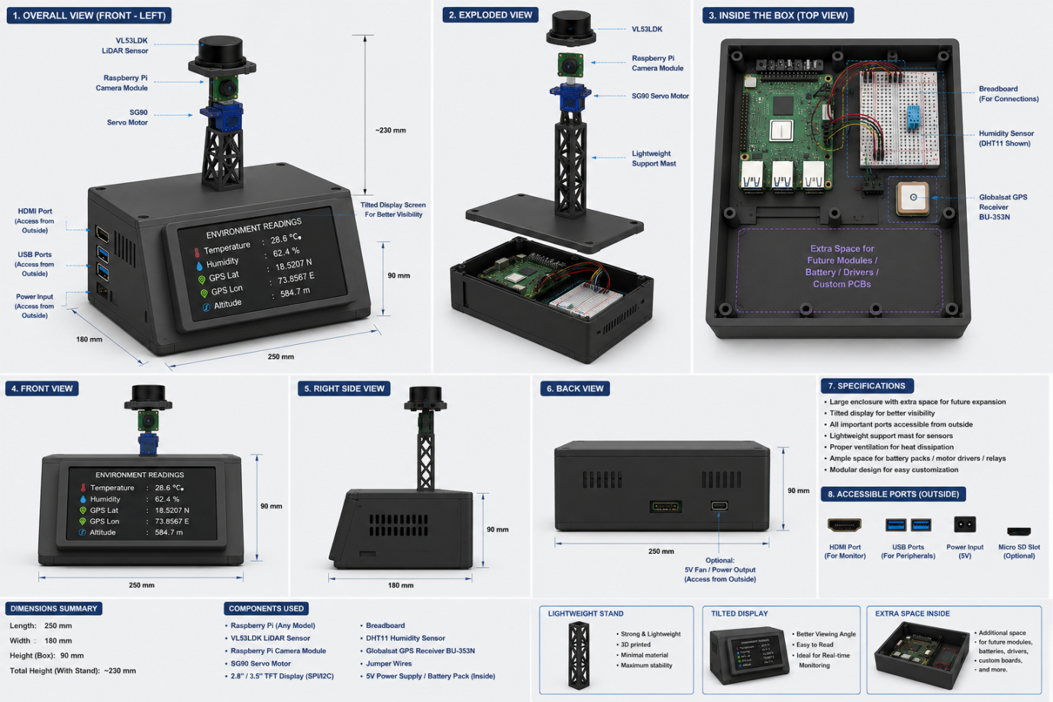
Figure 8: 3D Printed Prototype / CAD Model

